Cris Contini Contemporary presents

JEFF ROBB
BEYOND NATURE

5 – 15 October 2022

The Crypt Gallery – London

In the evocative setting of The Crypt Gallery beneath St Pancras Church, Euston Rd, London Cris Contini Contemporary presents ‘Beyond Nature’, the latest exhibition by lenticular artist Jeff Robb. The exhibition's extraordinary 3D images of flowers don't simply reveal the beauty of nature, they invite the viewer into a new realm – to go beyond appearances, to discover what lies behind a flower, to share in the mystery of nature.
Robb’s work is complex, the result of a passion for the world of botany combined with pioneering experimentation in 3D technology. Perhaps even more important, the work is a reflection of his deep concern with the human mind and how it functions. Playing with light and form, with scientific observation and surrealist whimsy, Robb guides the viewer into a parallel universe of beauty – it's a world of symmetry and formal order, as each flower is split into two identical halves, and yet it's a world of explosive colour and sensuous, undulating form.
‘I have a degree in botany that gave me a way to understand how plants work, their development and physiology,' Robb says. 'I am fascinated by their form and function – and their infinite beauty. The bifurcation of each flower allows us to look beyond nature including the symmetry that allows the mind to invent and rebuild perfection.'
Each work begins with the simple appreciation of flowers. Robb studies hundreds of flowers, different varieties, colours and shapes. The selected flowers are then shot in 3D and digitally 'sculpted' to create the final work.
In the work, Robb explores the way the human brain interprets information and the unresolved questions that logic and science cannot explain. These concerns are at the heart of his creative poetics.
‘I’m interested in the world of physics,' he says, 'and the things that science can’t really respond to, like light and time. We still don’t know what light or gravity is. However, as an artist, my primary goal is to create visually interesting works and the reason behind my work is of secondary importance. Artists ask questions, they don’t answer them.’
Observing one of Robb’s photographs is like looking at the famous inkblots of psychiatrist Hermann Rorschach. By folding the paper while the ink was still wet, he would attain a bilaterally symmetrical image and then ask viewers what images they see in the blot. Similarly the viewers of Robb’s images see more than just flowers. Before your eyes, petals become drapes or waterfalls, butterflies or otherworldly creatures. Likewise, pistils and stamens become dancing figures.
Sixteen works are on display, including photographs and holograms. From the entrance hall of the Crypt Gallery onward, the experience is immersive. In the main nave, a series of images of backlit ‘holographic’ flowers lead to Jeff's reinterpretation of the National Gallery's painting Flowers in a Terracotta Vase by the Dutch artist Jan Van Huysum. Jeff Robb has reimagined the painting in photography, transforming it into three dimensions, and even including butterflies of the original.
You can also admire one of the first holograms made by the British artist while still attending the Royal College of Art: using a laser with an exposure time of 25 nano seconds, less than the wavelength produced by the light on a ruby, he created a white hologram of light reflection. It is one of the most complex holograms you can create and gave rise to techniques he used in later works.
The exhibition continues with other pioneering works in 3D technology, including The Looking Glass, a cubic glass bulletin board through which the 3D images look real and approach the quality of current science-fiction holograms. It is the first holographic desktop display for which no viewer is required.
Furthermore a huge 1 mile high flower sculpture from British artist Jeff Robb will be hovering in mid air above the Frieze London art fair this year via a partnership with SAN Land, an AR (augmented reality) art application for smartphones. Visitors at Frieze will be able to see the digital sculpture rotating high above them, accompanied by a progressively louder soundscape the closer you move towards it.

By clicking on the image on the phone screen, the viewer is taken to the website of Cris Contini Contemporary gallery, where information on the exhibition of 3D ‘holographic’ lenticular prints can be accessed. The SAN App will also create a trail of giant, full colour flowers above the streets of London which lead the way to the show venue in Euston, the famous Crypt gallery situated underneath St Pancras Church.
Robb sums up his philosophy: ‘I am trying to overcome the barrier between painting, photography and sculpture. It’s completely uncharted territory, but I’m trying to cross boundaries as a medium.’
This exhibition is the perfect expression of that philosophy. It is an invitation to transcend appearances, to look beyond the image, to discover new and unexpected worlds.

PRESS FOLDER:
Link: https://bit.ly/3zD9byp

JEFF ROBB
A graduate of the Royal College of Art in 1992 with a Master in Fine Art Holography, Jeff Robb is known for his ceaseless experimentation in lenticular photography, for his open artistic approach, and for his mastery of cutting-edge tools and technologies. He works across many media: not just three-dimensional photography, but also painting, bronze and silver sculpture, holography for reflection and transmission, film, laser sound and light installations. Shortly after graduation, he was invited to present a landscape work to the permanent collection of the Victoria and Albert Museum in London. It was the museum's first-ever holographic acquisition. He also has works in the Museum of Fine Arts, Houston, the private collection of Her Royal Highness Princess Firyal of Jordan, and the Getty Museum, Los Angeles. He has undertaken many photographic commissions for artist Chris Levine, including the portraits of Queen Elizabeth II, Kate Moss, the Dalai Lama, Grace Jones and Banksy.

CRIS CONTINI CONTEMPORARY
The international gallery Cris Contini Contemporary was founded in 2018 by Cristian Contini and Fulvio Granocchia. Located in the heart of London, in central Mayfair, has recently opened a new branch in Montenegro. Cris Contini Contemporary offers collectors around the world access to an eclectic and multicultural portfolio of artists: from the great modern masters such as Pablo Picasso, Lucio Fontana, Andy Warhol and Robert Indiana, to the most appreciated contemporary artists such as David Begbie, Endless, Antonio Freiles, Michelangelo Galliani, Ferruccio Gard, Gioni David Gioni, Lorenzo Puglisi and many others. Thanks also to its continuous new international collaborations, Cris Contini Contemporary is an unmissable point of reference for enthusiasts and art collectors all over the world. www.criscontinicontemporary.com
SAN App
SAN App is a unique, planetary-scale Augmented Reality (AR) mobile application designed for unlimited scalability, flexibility, and creativity. The application was developed as a wholly new and unique solution for developing and deploying GPS-based large-scale virtual structures and artworks, among other possibilities. It can dynamically manage hundreds of kilometers of GPS-based AR objects and seamlessly integrate these virtually into any targeted physical environment (e.g., outdoor venues, conference centers, corporate lobbies, etc.) and does so in a hyper-realistic 1:1 scale ratio. When moving in the real space, the viewer also navigates in the augmented reality space of the SAN App in identical scale and proportions via the user’s smartphone, tablet, or other mobile devices. The SAN App is available on www.san.land, App Store, and Google Play.

SAN METASPACE
SAN METASPACES are common virtual spaces created in the approximate sizes of cities. They can include numerous virtual environments of SAN object owners, each identified according to its specific geolocation. When entering each SAN object owner’s domain, only the objects dedicated to that specific location are opened for viewing in the App. It is also possible to include, for example, a city map, marked event routes, or kilometer-long informative banners in the common SAN METASPACE.

Download the app iOS and Android

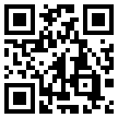

Beyond Nature - Jeff Robb
5 - 15 October 2022

Opening Tuesday 5th October - at 6.30 PM

Private Tour and aperitif with the artist – Thursday 13th October - at 6.30 PM
Invitation only: rsvp@criscontinicontemporary.com

Hours:
Monday – Friday: 10.30 AM – 6.30 PM
Saturday and Sunday: 12.30 PM – 6.30 PM

The Crypt Gallery
St Pancras New Church
165 Euston Rd Londra NW1 2BA

PRESS OFFICE:
Barbieri & Ridet: info@barbieriridet.com
tel +39 02 58328232

Organised by | In collaboration with
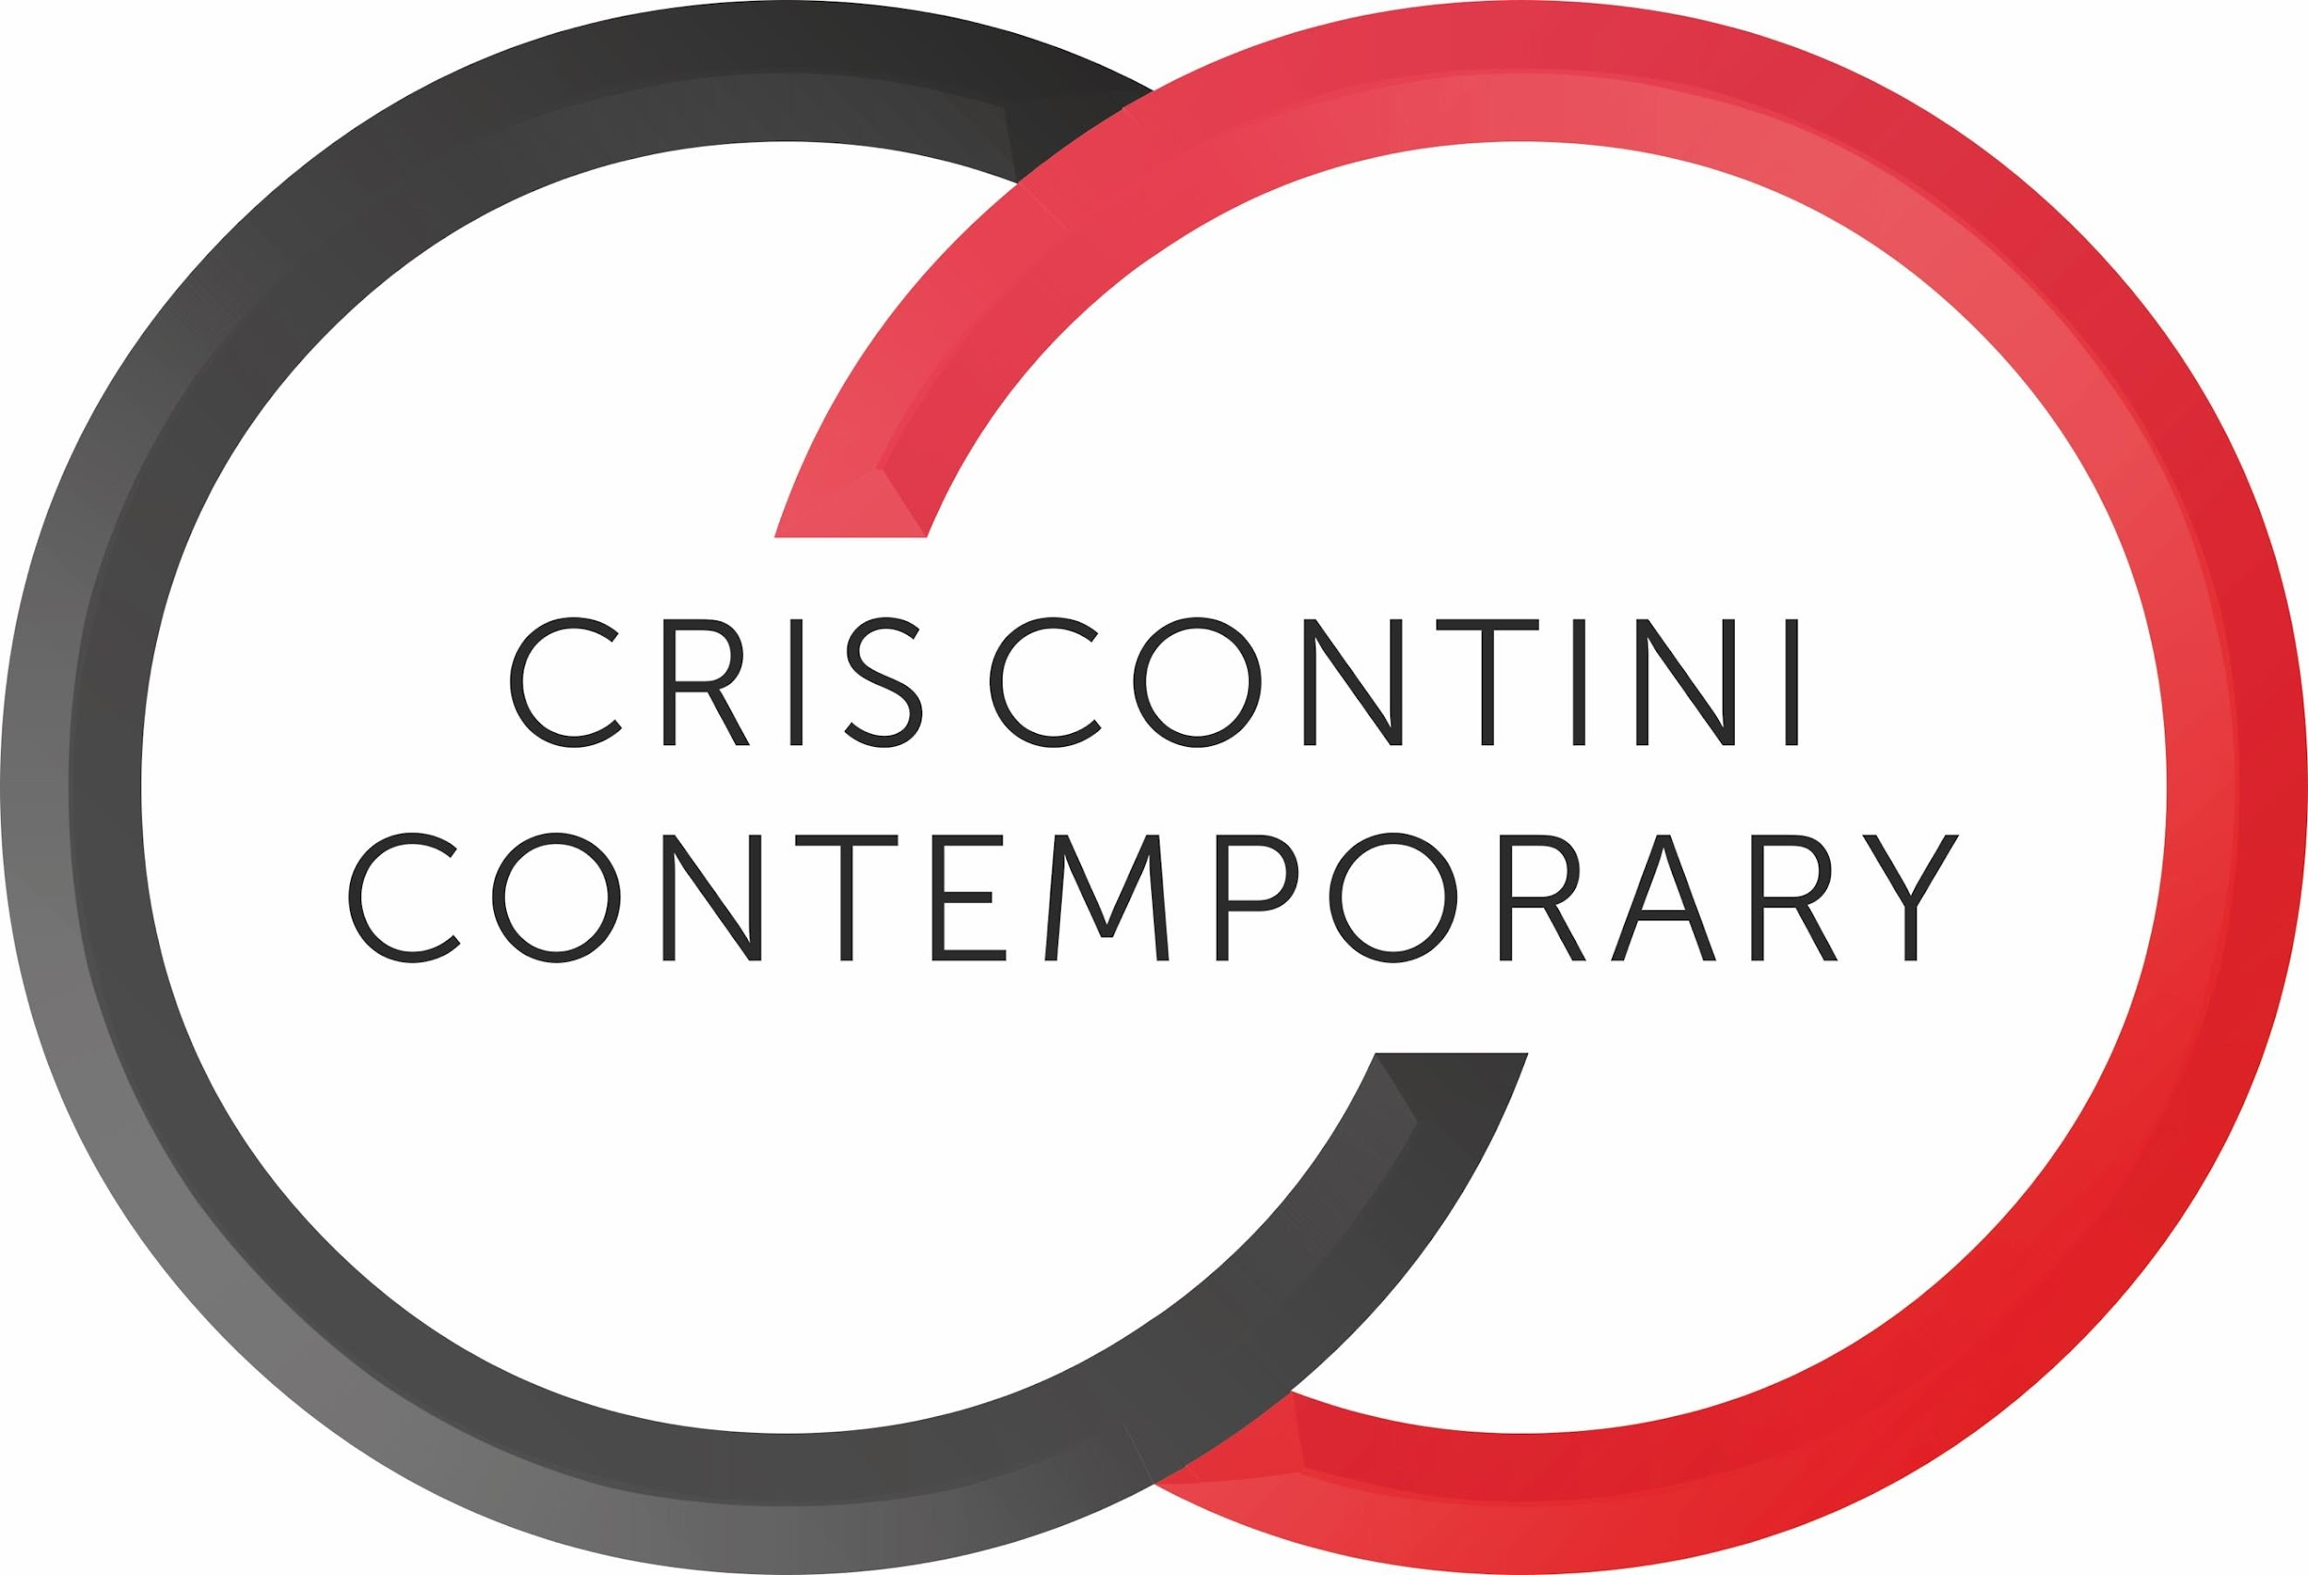 |  | 